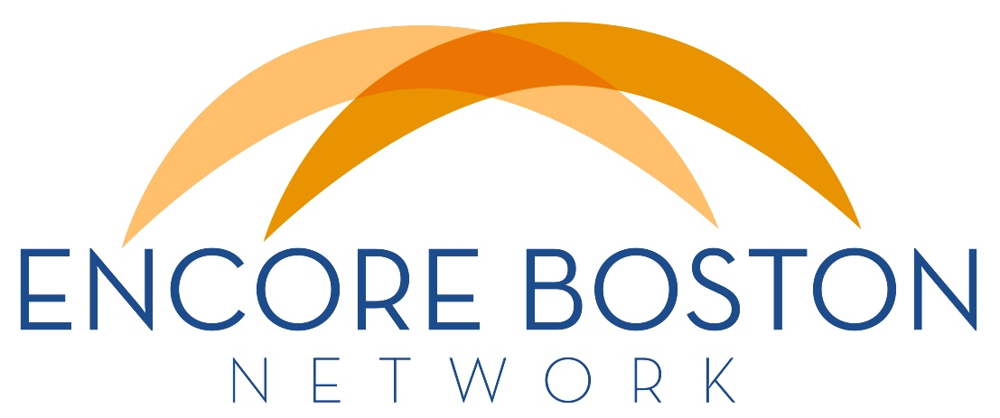
NEWSLETTER
AUGUST 18, 2015

Encore Expo 2015
November 18, 12:00 – 6:00 PM, Boston College
Experience Makes a Difference
We expect to connect 200 seasoned professionals with about 30 organizations that are making a difference in their communities. If encore talent is making a difference in your programs and you want to introduce your organization to new recruits, you’ll want join us at this inaugural Encore Expo on November 18th.

Be an Exhibitor! You can participate in four ways: 1) Set up an exhibit table, 2) Offer a 15-minute info session, 3) Place an ad in the program, and 4) Join in structured networking. See our website for more details and to reserve your spot. Note that as an EBN member, you can participate at a much lower cost.

We're grateful to lead sponsors Boston College Institute on Aging, Hartford Center of Excellence in Geriatric Social Work, and AARP MA for making this event possible. And thanks to our inspiring keynote David Campbell, Founder & Chair of All Hands Volunteers and Encore.org Purpose Prize Winner. But most important to the success of this Expo is your expertise, experience and engagement – it will make all the difference.

Become an EBN Member
As a reminder, we have begun signing up members as a way to help cover our costs. Membership levels and benefits are detailed here. To join, email encoreboston1@gmail.com with your name, organization, mailing address, phone number, and type of membership desired. You'll receive an emailed invoice with instructions on how to submit your dues. EBN members receive great discounts for Encore Expo 2015 as well as quarterly meetings, plus many other benefits.

CHANGE CREATES OPPORTUNITY
Bethany Kendall has announced that, effective Friday, October 2, she will be stepping down as ESC's President & CEO to become Executive Director of the Amelia Peabody Charitable Fund, an independent private foundation. After ten years leading ESC and many more in the nonprofit sector, Bethany is filling a long-held career goal to benefit the sector through a role in grant making. A search committee has been formed to find a replacement and applications are welcome. A job description is attached.

There is also a CEO position open at Friendship Home, which provides respite care and support services to individuals with development disabilities and their families. The job description is attached.

NEW ONLINE TOOL FOR MATURE WORKERS
Unemployed older workers have been hardest hit by the recession and slow recovery. To address this, RetirementJobs.com and the National Council on Aging have joined forces to provide opportunities specific to this segment of the workforce. An online tool called EconomicCheckup offers skills assessment, online training and help finding a job. See the full announcement here.

NEW PROGRAM FOR MANAGERS IN AGING
Lasell College and ELDER Management Education have launched a new Strategic Management Track for leaders in the aging field. The program consists of five mini-management courses taught by professors and experts in aging services. More info about the courses and registration is available here.

FROM BOSTON TO NORWAY
The Norwegian Ministry of Labor's Center for Senior Policy has invited Elizabeth Fideler to address an international seminar in Oslo in September about her studies of mature workers choosing to stay on the job. An EBN member and research fellow at Boston College's Center on Aging & Work, Dr. Fideler is the author of Women Still at Work (2012) and Men Still at Work (2014), both from Rowman & Littlefield Publishing.

ENCORE OPPORTUNITIES
SOAR 55, Your Local Resource for Volunteering, places, trains, and supports volunteers, age 55 and over, who want to use their skills and experience to provide critical assistance at local nonprofits and public organizations in Newton and Metro West. With 90 nonprofit and public partners and a unique and personalized matching approach, SOAR 55 offers easy access to a variety of volunteer assignments that match the right opportunities to interests, values, and schedules. To learn more go to www.soar55.org or contact Jan Latorre-Stiller at jlatorre-stiller@soar55.org.

ESC of New England is currently recruiting senior-level professionals as volunteer consultants, presenters, facilitators, and as paid Encore Fellows. ESC provides high quality consulting and capacity building support to nonprofits in Massachusetts and Rhode Island by leveraging the skills and experience of the Encore community. Through our Professional Development Institute, presenters are able to share their expertise with nonprofit leaders. If interested in learning more please, visit the ESC website at www.escne.org or contact Ulea Lago at ulago@escne.org.

ReServe Greater Boston connects professionals 55 plus with stipend work opportunities at local nonprofits and public agencies. Learn more about how ReServe Greater Boston can help put your experience to work by attending a free information session called First Impressions on Tuesday, September 15, in Watertown. Registration is required at www.reserveinc.org/greaterboston.

COMING EVENTS
Revolutionize Your Retirement: Interview with the Experts
Tuesday, August 25, 12:00 – 1:00 PM. Free and open to professionals and the public. Sign-up by August 18th at www.revolutionizeretirement.com.
Helen Dennis, expert in aging and retirement and co-author of Project Renewment: The First Model for Career Women will join host Dorian Mintzer. Topic: Age & Retirement: Four Game Changers. These include the Village movement, encore careers, technology and a response to retiring career women. Join in for an informative, lively and "fun" conversation. Contact dorian@dorianmintzer.com with questions.

Boston Bridge Meeting
Wednesday, September 16, 6:00 -8:00 PM, Sloan School of Management at MIT, Room 550. All are welcome.
Boston Bridge, a professional development and mentoring organization for emerging leaders in the field of aging, will hold its first meeting of this year. Senator Pat Jehlen, Chair of the Joint Legislative Committee on Elder Affairs, will be the evening's speaker.

The NEW Volunteering: Purposeful, Flexible and Meaningful
Wednesday, September 30, 7:00 - 8:45 PM, Newton Free Library, 330 Homer Street, free.
Explore how a volunteer experience can be a pathway to change, new connections, self-fulfillment, and wellbeing. Rediscover a passion, use your skills and learn new ones, or just make a difference. Hear from volunteers who will share their stories of service and transition. For more info, contact Karen Albert at kalbert@soar55.org.

Pathmaking for Life
Six sessions between October 6 and November 17, 6:30 – 8:00 PM, One Washington St, Wellesley Hills, Suite 305. Limited to 6 attendees; reduced fee if registered by 9/4.
This workshop, facilitated by Roberta Taylor, is targeted to women in midlife and beyond who want to move forward in their lives while benefiting from the power and support of a group. More info at rkt@pathmaking.com.

MA Gerontology Association Fall Policy Forum
Friday, October 23, 9:00 AM - 1:00 PM, Lasell College.
Leaders from aging services organization will discuss policy challenges and priorities, as well as opportunities for emerging leaders in the field. Given the relevant topic, Boston Bridge will be a cosponsor of this event! Save the date – more info to come.

Discover Your Encore
Thursday, October 29, 7:00 PM, Wellesley Free Library, 530 Washington Street. Free admission, open to all.
Explore volunteer or paid work with a social purpose, how to target your search and find opportunities that combine personal meaning and social impact. Presented by the Wellesley Council on Aging and the Wellesley Free Library, and offered by Discovering What’s Next, a program of ESC of New England, under a grant from The Fund for Wellesley with additional support from Middlesex Savings Bank.

