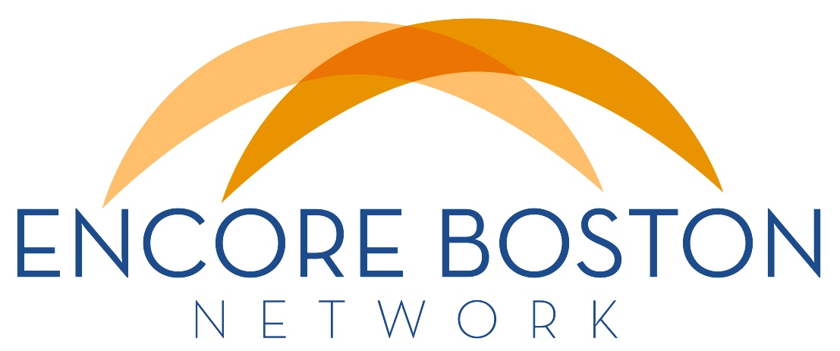
NEWSLETTER
January 16, 2015

DECEMBER EBN member meeting
About 30 members attended the EBN meeting on December 18 to help finalize our goals and objectives for 2015 (see next article). A list of possible goals was proposed based on previous discussions, our business plan, a member survey and board input. This list was refined at the meeting and affirmed by the board immediately following. Thanks to AARP for use of their conference room!

A copy of the presentation slides is attached if you would like to review them. In addition to the proposed goals and objectives, helpful graphics show how they relate to each other, how we fit into the encore ecosystem and the process we used to set our 2015 priorities.

GOALS & OBJECTIVES for 2015
2015 is going to be an action-packed year for Encore Boston Network. At our meeting in December, we formed three action teams to focus on the following goals and objectives:
ALIGN & STRENGTHEN: Create channels for communicating member needs, resources, & opportunities -and- Coordinate with Encore Network to develop a knowledge & resource sharing system.
EDUCATE & PROMOTE: Coordinate with Encore Network to develop standard messaging -and- Develop a media kit & outreach plan.
BALANCE SUPPLY & DEMAND: Develop a collective recruiting process -and- Pursue opportunities to adapt existing employer engagement programs to Greater Boston.

The board will tackle a separate goal we’re labeling BUILD AND FUND BACKBONE: Continue to build out EBN infrastructure -and- acquire funding to support our operating costs.

There will be monthly conference calls (no longer than one hour each) with the possibility for assignments in between. If you haven't already, please indicate your preference for volunteering by completing this 2-minute survey:
https://www.surveymonkey.com/s/PSM53TW

2015 CALENDAR for member meetings
We're planning an engaging series of quarterly meetings this year. Please save these dates on your calendar now so you’ll be able to participate:
Friday, March 6, 9 am – 12 pm
Friday, June 5, 9 am – 12 pm
Friday, September 18, 9 am – 12 pm
Friday, December 4, 9 am – 12 pm

You’ll be hearing more details soon. Meanwhile, if you have any topic or speaker suggestions, please send those to Cathy Kang.

POST NONPROFIT JOBS FREE on RetirementJobs.com
Tim Driver has created a place on the RetirementJobs.com website for nonprofit jobs to be posted free of charge. This Encore Offer applies to the first 5 nonprofit postings and includes either paid jobs or volunteer positions.

Here are the steps:
Click on 'employers' tab on the blue menu bar (on any page on RetirementJobs.com)
Click 'Post a Single Job' on the top right side of page
Fill out the 'Employer Registration'
Click 'Post Jobs'
In the billing section, use the 'Redeem Coupon' choice and enter 'retirementjobs-7818905050' (without the quotes)

ENCORE ENTREPRENEURSHIP Seminar on Feb 12
The Small Business Development Center, AARP and the Small Business Administration will hold an Encore Entrepreneurship Seminar at Salem State University on Thursday, February 12 at 8:00 – 10:00 am. People over 50 are starting more businesses than any other age group. If you know anyone who is interested, a flyer with details is attached courtesy of Ray Milano of SBA.

WINTER FITNESS CLASSES
If you have program volunteers or others who might be interested in free or moderately priced fitness classes, contact Mary Stevenson to learn more about Zumba Gold, Nia Technique and other programs offered in venues in Boston, Brookline and Newton.

SHARE your news!
Please let us know if you have news you'd like to share with other EBN Newsletter readers. This might include new developments, programs to share, partnership opportunities or resources of general interest. The newsletter is published monthly, so send time-sensitive info during the first week of each month to Cathy Kang or Doug Dickson.

Cathy Kang, Executive Director
Doug Dickson, Board Chair

