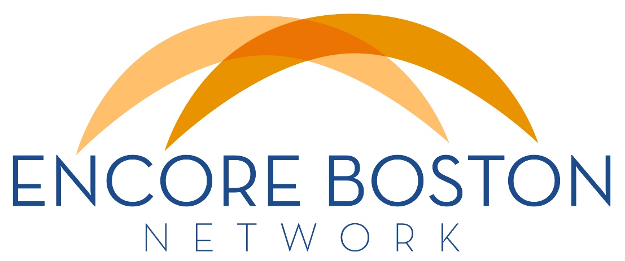
NEWSLETTER
October 26, 2014

Encore Boston Network has a logo!
Our new logo features dual arches (orange -- not golden!) that symbolize connection among network members, but also between encore talent and encore opportunities. The arches themselves suggest the dual role of pathway programs: recruitment/preparation and placement. They are also reminiscent of stage lights, in keeping with the encore performance theme. The orange and blue color scheme links visually to Encore.org and the Encore Network, which use similar colors. We hope you like the clean, bright and open feel of our EBN logo.

And we have a new website!
Our new web address is www.encorebostonnetwork.org, where you’ll find phase 1 of our website. To start, we have a Home page and About page, with placeholders for additional pages, which will feature info for Individuals who want to learn about encore, Organizationswho want to offer encore opportunities, and Advocates who want to support our mission. Those pages, along with Resources, Calendar and Donate pages will be added down the line. Thanks to Chuck Yanikoski, our Encore Innovation Fellow, for making us visible on the web. We invite comments and suggestions for adding to or improving our site.

We also have new Mission, Vision and Values statements!
At its first meeting, our new board approved revised statements that we hope will be inspiring and memorable.

Mission (our purpose, target and means – why we do what we do)
The mission of Encore Boston Network is to strengthen our communities by engaging the talents of people in midlife and beyond.

Vision (the desired end state of our efforts – what we do)
We envision a Greater Boston in which people of all ages experience an enhanced quality of life.

Values (how we put into action our essential beliefs)
- Put the people we serve 1st
- Connect with respect
- Explore the unexpected
- Create shared value
- Get results
These statements offer a guide for the development of strategies and goals, help us define our shared agenda and frame our interactions with each other. Next steps will include defining short-term projects, a needs analysis, and mapping the network to better understand existing connections, gaps to fill and opportunities for closer collaboration. Look for more to come soon on this topic.

Thanks to Cathy Kang and the board for their leadership in helping us clarify our what, why and how statements. Feedback is always welcome!

EBN Member meeting planned for mid-December
We’ll be announcing a date, time and place for our next member meeting shortly. Our focus will be on mapping the network, identifying common challenges, and developing short-term strategies. We hope you will join us and we look forward to getting our group together again soon.

Purpose Prize winners announced
Six remarkable individuals will be honored at the annual Purpose Prize ceremony this week in Tempe, Arizona. You can read about them, along with 38 Purpose Prize Fellows, by clickinghere.

Winners and Fellows from Massachusetts include David Campbell, founder and chairman of All Hands Volunteers; Stella Aguirre McGregor, founder, executive director and artistic director of Urbano Project; and Judge William Abrashkin, executive director of the Springfield Housing Authority. Congratulations to these and all the other 2014 Purpose Prize Winners and Fellows. Nominations for 2015 Purpose Prizes are now open. Spread the word to any you think might be interested.

PS -- You can see all the past Purpose Prize Winners and Fellows from our area on our new web site!

Media opportunities
You may have seen news earlier this week about a report from MassINC that forecasts an upcoming hole in the workforce that will result in a drop in overall educational levels in Massachusetts for the first time in recent history. At Carol Greenfield’s suggestion, Doug Dickson posted a comment about how encore talent might help close this gap. Read the Globe article and comment here.

This is a good example of ways we can begin to get our message out. If you uncover opportunities like this, please refer them to Cathy or Doug, or post your own comments and let us know about them so we can share them with others.

Cathy Kang, Director
Doug Dickson, Board Chair

