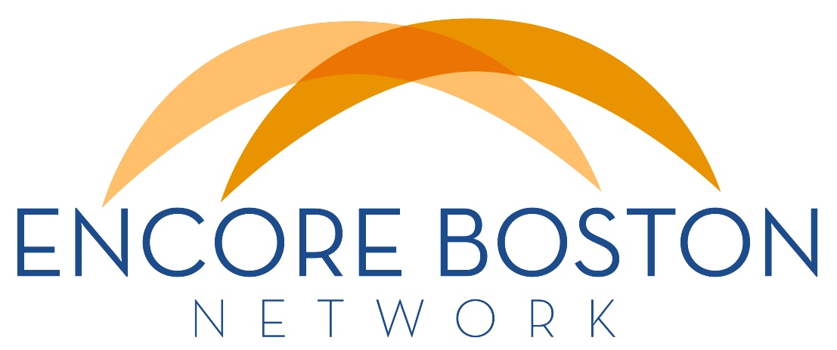
NEWSLETTER
February 12 + 15, 2015

SEEKING COMMUNICATIONS and Marketing Skills
Our 2015 goals and objectives focus on building awareness and visibility for the encore idea, the Encore Boston Network and our member organizations. Our action teams are putting together exciting plans to achieve these goals. To help lead this effort, we are searching for someone with relevant communications and marketing experience. The skills and qualifications we seek are outlined in the attached job description for a Communications & Marketing Manager. This paid position is funded as an 8-month Encore Innovation Fellowship.

If you know anyone who might be interested, please feel free to forward the job description or refer them to Cathy Kang for further information. We're hoping to have someone on board as soon as possible.

MARCH 6 MEMBER MEETING: Recruiting Encore Talent
Research consistently shows an abundance of people interested in encore roles. Yet those responsible for recruiting and matching talent to encore opportunities report a variety of challenges:
- Finding specific skill sets, cultural fits or work styles,
- Generating the flow of talent at points when it is most needed,
- Attracting racial, ethnic, cultural and socioeconomic diversity,
- Addressing the lifestyle and flexibility needs/preferences of recruits, and
- Offering supports and services that keep talent engaged over time.
To help us think through these challenges and come up with some strategies, we're assembling a panel for our meeting on Friday, March 6 (9 am - 12 pm). More details coming soon, but put this meeting on your calendar now so you don't miss this important discussion. And let Cathy Kang know what your specific recruiting issues are if they're not included on the list above...

FUTURE MEMBER MEETINGS
If you've not already done so, please add these future EBN member meetings to your 2015 calendar:
- Friday, June 5 (9 am - 12 pm)
- Friday, September 18 (9 am - 12 pm)
- Friday, December 4 (9 am - 12 pm)
Our program planning group has some great ideas for these sessions, but if there's a topic you'd like us to focus on, please let Cathy know so we can get it into the mix.

GALLUP: OLDER WORKERS More Engaged
A new survey of employee engagement concludes that older baby boomers who remain in the workforce are more engaged than their younger colleagues. Higher engagement, Gallup says, "may indicate that those who choose to continue working are more likely to do so because they find their work fulfilling. It is also possible that as workers age, they become increasingly better at finding work that suits them."

Of course, encore offers just that chance to find work with meaning and purpose, leading to greater fulfillment and engagement. Read more about the survey here.

THE CASE FOR ENCORE: Tina Matz-Costa
The Institute on Aging at BC has created a series of videos titled "BC Talks Aging." The second in the series addresses Social and Productive Engagement and features EBN board member and BC assistant professor Tina Matz-Costa. She makes the academic case for the work we all do.

A lot of good info is packed into this 14-minute summary of research findings and current thinking and it should be one of the professional development tools we all use with our staffs to convey the importance and impact of our work. Take a few minutes to watch this video here.

ReSERVE INFO SESSION on February 20
ReServe Greater Boston promises no snow for Friday, February 20 when it hosts a First Impressions information session in Watertown. If you know of professionals 55 plus who are looking for ways to use their skills and experience, make a difference and earn some money, tell them to attend this session. Check here for more information and to register.

ESC CORE COURSES begin March 5
These courses are designed to prepare volunteer consultants, volunteer workshop presenters, and stipended Encore Fellows for various roles in the nonprofit sector. If you know anyone interested in learning more about these opportunities, please pass this info along. ESC is particularly looking for people with expertise in fundraising, outcomes measurement, organizational development, and marketing.

For more information about becoming an Encore Fellow (stipend), please contact Donna Morelle. To learn more about becoming a volunteer consultant or workshop presenter, please contact Ulea Lago.

OUR AGING MARKET - March 5 HBS Event
You know a tipping point has been reached when Harvard Business School convenes a group of leading US consumer businesses to talk about the purchasing power and business potential of the Aging Market. This event will be held on Thursday, March 5 (5:00 - 9:00 pm) and will feature Joe Coughlin of the MIT AgeLab as the keynote speaker. A variety of other speakers will fill out several panels, leading to interactive discussions. This event is open to the public. Event and registration info are available here.

ELDERCARE PRACTICE LEADER: myElderGPS
A local firm called EnCompass Education Solutions is looking for an eldercare professional to lead development of a new online platform. This tool will act as a virtual advocate and assistant for families and others who are in need of eldercare services. It is modeled on a similar program developed for families of special needs children. If you know of anyone with the credentials for and interest in this position (could be a great encore for the right person!), details are available in the attached job description or by clicking here.

AGE-FRIENDLY BOSTON Holds Community Meeting
On Saturday, February 28 (9:30-11:30 am) at Faneuil Hall in Boston, Mayor Walsh will convene what he is calling a Civic Academy, an opportunity to hear input from community members and organizations about the Age-Friendly Boston initiative.

Using World Health Organization guidelines, Age-Friendly Boston seeks to challenge the city's public agencies, businesses, cultural, educational and religious organizations and community groups to consider how changes to policy and practice can enhance the quality of life for our older residents.

In addition to obvious issues like housing, transportation and health services, the city is also looking at civic engagement and employment, respect and social inclusion, and social participation as areas of focus. Those are areas in which we have real expertise and experience to offer.

This community meeting is an opportunity for us to encourage our volunteers, host organizations, staff members and others to carry the message that encore programs need to be recognized, elevated and expanded as a solution to this range of issues.

Registration and further information is available at this link.

SHARE your news!
Please let us know if you have news you'd like to share with other EBN Newsletter readers. This might include new developments, programs to share, partnership opportunities or resources of general interest. The newsletter is published monthly, so send time-sensitive info during the first week of each month to Cathy Kang or Doug Dickson.

Cathy Kang, Executive Director
Doug Dickson, Board Chair

